Contents
ABSTRACT 3
1.INTRODUCTION 5
2. LITERATURE REVIEW 7
2.1 Climatic Changes and Trends in Bangladesh 7
2.2 Monsoon Dynamics and Seasonal Transitions 8
2.3 Clustering Techniques of Regionalization and Classification 9
2.4 Dynamic Time Warping in Climate Applications 10
2.5 Summary of Research Gap 10
3. DATA AND METHODS 11
3.1 Data Sources and Study Period 11
3.2 Climatic Variables Used in the Analysis 13
3.3 Missing Value Imputation 15
3.4 Feature Importance 18
3.5 Seasonal Clustering and Algorithm Validation 19
3.5.1 Feature Standardization and Algorithm Selection 19
3.5.2 Model Validation 20
3.5.3 Statistical Validation and Significance Testing 21
3.6 Multidecadal Phase Change Analysis 23
3.6.1 Dynamic Time Warping for Temporal Seasonal Comparison 23
3.6.2 Mathematical Framework 24
3.6.3 Phase Shift Detection 24
4. RESULTS 25
4.1 Importance of Climatic Features 25
4.2 Monthly Climate Profiles and Heatmap Analysis 26
4.3 Cluster Validation and Algorithm Comparison 28
4.4 Empirical Seasonal Classification 31
4.5 Rainfall Distribution and the Post-Monsoon Cluster 33
4.6 Multi-Decadal Changes and Phase Shifts 34
4.6.1 Statistical Assessment of Temporal Seasonal Reclassification 40
4.6.2 Variable-wise Analysis (Mann-Whitney U Test) 41
4.6.3 Validation of Seasonal Acceleration (Bootstrap CI) 41
4.6.4 Cluster Stability and Frequency Distribution 41
4.7 Spatial Variation 44
5. DISCUSSION 46
5.1 Reconsideration of the Traditional Seasonal Calendar 46
5.2 Climatic Drivers of Seasonal Identity and the Wind Speed Signal 47
5.3 Acceleration of Climatic Restructuring 47
5.4 Regional Heterogeneity and Practical Implications 48
5.5 Limitations and Future Research 49
6. CONCLUSIONS 49
Data availability 51
References 52

List of Tables
Table 1. Descriptive Statistics of the Imputed Dataset (1983–2014; n = 13,164 station-months) 17
Table 2. Comparative Performance of K-Means, Gaussian Mixture Model, and Hierarchical Agglomerative Clustering.. 29
Table 3. Empirical Seasonal Characteristics based on K-Means Clustering (1983–2014) 32
Table 4. Dynamic Time Warping Distances among Three Climatic Decades. 35
Table 5. Decadal Variable Means and Significance 37
Table 6. Decadal Boundary Reallocation of Seasonal Months 38
Table 7. Summary of Statistical Significance Tests for Decadal Climate Shifts. 42

List of Figures
Figure 1. Map of Bangladesh showing the locations of the 36 stations used in this study (1983–2014). 13
Figure 2. Pearson correlation matrix for the seven meteorological variables (1983–2014). 15
Figure 3. PCA variance explanation that demonstrates the importance of rainfall and thermal variables. 26
Figure 4. Averages of the monthly climatological data (1983-2014) with cluster-coded bar colors. 27
Figure 5. Z-score heatmap of climatic variables synchronization of seasons. 28
Figure 6. Internal validation indices identifying the optimal four-cluster solution. 29
Figure 7. Hierarchical dendrogram (Ward linkage) that supports the four-cluster structure. 31
Figure 8. July, October and January Rainfall PDFs. 33
Figure 9. Decadal climatological profiles showing multi-variable seasonal divergence. 35
Figure 10. Variable-wise DTW distances. 36
Figure 11. Heatmap of decadal cluster assignment. 39
Figure 12. Phase shift analysis (Decade 1 vs. Decade 3) month-wise. 40
Figure 13. Seasonal cluster assignments of the stations of Bangladesh. 45

ABSTRACT
Traditionally, Bangladesh defines six seasons based on agricultural and cultural experience accumulated over centuries (Banglapedia,2021), but their validity under contemporary climatic variability remains uncertain. This research re-evaluates the empirical seasonal structure of Bangladesh using 32 years (1983-2014) of monthly observations in 36 meteorological stations, and totals 13,164 records in seven key variables. After reconstruction of data according to the WMO standard, the Principal Component Analysis showed that three components explain 88.75% of climatic variance with rainfall, as the most dominant factor. Comparison of K-Means, Gaussian Mixture Models, and Hierarchical clustering, the K-Means four-cluster solution was found to be the most statistically robust model.
The results demonstrate that the traditional six-season framework is no longer supported by meteorological data. Rather, it can be identified as a four-season regime: Winter (Nov -Feb), Pre-Monsoon (Mar-May), Monsoon (Jun-Sep), and Post-Monsoon (Oct). Dynamic Time Warping (DTW) analysis confirms an acceleration of seasonal restructuring, with the decadal divergence distance increasing from 0.474 to 0.904 between the initial and latest periods of the study. Statistical validation using Mann-Whitney U tests shows that 33.3% of the annual cycle, that is the transition months of March, April, October and November have experienced a significant reassigning of clusters. While wind speed showed low static clustering contribution, it emerged as the most sensitive indicator of decadal displacement. These results underline a statistically quantifiable rearrangement of the seasons of Bangladesh, requiring a transition to a data-driven classification of the future agricultural and environmental policy.
Keywords: Seasonal Re-Classification; K-Means Clustering; Dynamic Time Warping; Climate of Bangladesh; Unsupervised Machine Learning, South Asian Monsoon

1.INTRODUCTION
Bangladesh is located in the humid tropical monsoon region of South Asia $(20°N-26°N),$ where the South Asian Monsoon controls the annual rainfall, temperature, and irrigation water throughout the country(M. S. Alam & Paul, 2020; Turner & Annamalai, 2012). Bangladesh features a humid monsoon tropical climate that exhibits great seasonal variation in its rainfall distribution (Rashid, 2019), with about $80\%$ of the rainfall recorded during the June-September monsoon season. For decades, this climate has enabled the development of Bangladesh’s agrarian economy, where the rice crop accounting for more than $70\%$ of the cultivated lands - is cultivated according to monsoon dynamics.
The classic Bengali seasonal cycle identifies six different seasons - Grishma (summer; April-May), Barsha (monsoon; June-September), Sharat (autumn; October-November), Hemanta (late autumn; November-December), Sheet (winter; December-January), and Basanta (spring; February-March). Historically, each season corresponds to certain types of agriculture, crops, harvesting times, and cultural events based on many years of accumulated experience. Such a system offered a sufficiently operational climate scheme during those eras when the climate was relatively stable (Shahid, 2010). The relevance of this system in terms of modern weather data remains unexplored.
A growing number of observations suggest that the climate system of Bangladesh no longer adheres to its historical cycles, which form the basis of its conventional seasonality. There have been statistically significant warming trends noted at several meteorological stations (Mullick et al., 2019). In addition, an estimated temperature increase of $(+1.0°C)$ by 2030 will occur, along with extreme precipitation events that increase the chances of flooding and droughts (E. Alam et al., 2023). Long-term studies show an increase in average temperatures, increased irregularity in the time of arrival and departure of monsoons, extended pre-monsoon heatwaves (Rimi et al., 2019), and shorter winters (Mullick et al., 2019). Such changes affect the efficiency of agriculture because farmers need to adapt to the altered crop calendar, which was previously linked to the historical seasons (E. Alam et al., 2023). (Bosu et al., 2021) found a clear discrepancy between the seasonal rainfall predictions made by CMIP5 models and the observed data, which could not be explained by natural fluctuations alone. (S. Rahman & Anik, 2020) also found a trend toward increased pre-monsoon heat waves, threatening the traditional definition of Grishma.
As the trend documentation method quantitatively documents directional trends in individual meteorological variables, the implicit assumption underlying the process is that the seasonal classification system used is empirically valid. However, before we establish changes in one of the many components of the seasons, it needs to be asked whether the months comprising any particular season behave cohesively under multi-dimensional observation. While previous research efforts have shown the presence of changing trends in assumed seasonality, no test has been made to see if the assumptions concerning seasons are still valid using the available data. (Islam & Kotani, 2016) studied 'changing seasonality' in Bangladesh; however, they did not propose any alternative seasonal classification based on objective examination of climate-related data. Similarly, (Mahmud et al., 2022) examined four homogeneous climate regions based on multidimensional clustering analysis but did not make a comment regarding seasonal boundary validity.
The objective of the present study is, therefore, to test season validity using empirical evidence extracted from 32 years (1983-2014) of seven variable meteorological observations from 36 stations in different physiographic zones of Bangladesh. In contrast to earlier work done on climate and agriculture in Bangladesh, we do not begin with the traditional six-season concept but examine it using multiple machine learning algorithms, namely K-Means, Gaussian Mixture Model, and Hierarchical Agglomerative Clustering, for identifying groups of similar months. For the temporal aspect, the dataset is first decadal stratified (1983-1993, 1994-2004, 2005-2014) and then subjected to Dynamic Time Warping analysis. The rate of change of seasons thus determined will prove useful in climate adaptation policies, including agricultural decision-making. In addition to the temporal aspects, spatial analysis of the 36 stations will reveal whether there needs to be region-specific seasonal classification systems in Bangladesh given its geographic heterogeneity.
The results of this study have implications for climate-responsible policy in Bangladesh. Crop calendars, agricultural extension programs, water resource management, disaster and climate change adaptation strategies are often developed with reference to historically assumed seasons. If these seasonal assumptions are no longer consistent with actual atmospheric patterns, then climate policy responses based on the conventional six seasons may become increasingly misaligned with climatic reality. Thus, a more data-driven assessment of seasonality is not simply descriptive, but essential to bolstering climate resilience in one of the world's most climate-vulnerable nations.

2. LITERATURE REVIEW

2.1 Climatic Changes and Trends in Bangladesh
Previous climatological studies on Bangladesh consistently indicate that the country is undergoing measurable atmospheric change. (Mullick et al., 2019) reported statistically significant warming trends at several stations, while (E. Alam et al., 2023) showed that increasing temperatures already have an impact on yield projections of Bangladesh's staple food crop, rice. Along with warming, the occurrence of extreme rainfall events has been increasing as reported by (Shahid, 2011), implying greater variability in rainfall concentration. Long-term records also show perceptible changes in rainfall patterns over various physiographic zones within Bangladesh by (Md. M. Rahman et al., 2021), while (Rimi et al., 2019) estimated the contribution of human-induced climate change to recent climate anomalies. In addition to temporal variations, a number of studies have identified significant spatial and temporal variability in the country's climate system. (Rafiuddin et al., 2012) discussed regional and seasonal variations of rainfall and highlighted the growing complexity of the monsoon over the major administrative divisions of the country. Likewise, (Sarker, 2021) demonstrated north–south disparities in temperature and rainfall characteristics, suggesting that responses are not homogenously distributed across the country. Also, (Md. M. Rahman et al., 2024) identified the spread of heatwave hotspots, showing an increased frequency of thermal stress in recent years, and (Abu Zafur Al-Munsur et al., 2025) presented annual and seasonal evidence of long-term trends in the major meteorological variables. Collectively, these findings confirm that the climate of Bangladesh is no longer stationary; however, they primarily document shifts in individual hydroclimatic variables rather than evaluating whether the broader seasonal structure itself remains climatically coherent.

2.2 Monsoon Dynamics and Seasonal Transitions
While documenting significant climatic changes, the majority of trend-based studies continue to assume the traditional seasonal calendar to be analytically valid without questioning whether current seasonal boundaries still align with present climatic conditions. In this context, (Turner & Annamalai, 2012) pointed out possible changes in the timing of monsoon onset and withdrawal, which could significantly affect seasonal transitions. Such concerns have been reiterated in agricultural studies of the impact of monsoonal variability (Shariot-Ullah et al., 2024) wherein delayed onset and early withdrawal cause chain reactions in the agricultural calendar, which was hitherto aligned with the six-season framework. (Bosu et al., 2021) compared climate model predictions under CMIP5 with ground observations and found significant differences in seasonal rainfall patterns, which could not be accounted for by natural variations. (Islam & Kotani, 2016) discussed the issue of "changing seasonality" in Bangladesh, yet failed to propose an alternative classification system based on empirical data. The reduction in winter season duration (Mullick et al., 2019) and increase in pre-monsoon heat waves (S. Rahman & Anik, 2020) further reinforce doubts about the relevance of traditional season classifications.

2.3 Clustering Techniques of Regionalization and Classification
(M. S. Alam & Paul, 2020) used several clustering methods to create homogeneous rainfall regions within Bangladesh, proving the effectiveness of multivariate techniques in capturing regional characteristics that otherwise would be neglected by univariate analysis. The researchers compared K-Means, hierarchical clustering, and fuzzy c-means and concluded that the choice of an algorithm significantly affected regionalization results and should be considered alongside validation measures for climatic classification.
In atmospheric sciences at large, regimes were identified using cluster-based methods in order to classify climates and detect climate changes (Christiansen, 2007). (Jain, 2010) reviewed 50 years of use of clustering in science since K-Means was first formulated, and explained that unsupervised learning posed challenges for environmental variables due to their spatiotemporal dependency. Machine learning is now recognized as a viable tool for predicting seasonal climate changes in climate zones (Ciftci et al., 2026) and seasonal rainfall (Das et al., 2024).
In the Bangladesh context, (Mahmud et al., 2022) also used multivariate cluster-based methods to classify climate regions. They identified four distinct regions based on temperature, rainfall, and humidity characteristics. However, despite the success of clustering in regional climate classification, its application to reassessing month-to-season identities within Bangladesh’s traditional calendar remains largely unexplored.

2.4 Dynamic Time Warping in Climate Applications
Dynamic Time Warping (DTW), initially devised for speech recognition and time series alignment (Keogh & Ratanamahatana, 2005), has become widely used in environmental and climatic applications. For example, (Laperre et al., 2020) have utilized DTW in forecasting geomagnetic storms, illustrating its ability to identify phase shifts in nonstationary time series when Euclidean distance-based techniques cannot do so. Furthering this development, (Virdee et al., 2023) have utilized DTW in climate model ensemble forecasts, providing evidence that DTW offers a time-invariant local metric for extreme event risk evaluation that surpasses correlations.
In agricultural remote sensing, (Teke & Çetin, 2021) used DTW across multiple years using vectors for crop type classification, successfully distinguishing phenological events that would be unidentifiable using alignment-dependent metrics. Due to its robustness to temporal warping, DTW is well-suited for identifying climate-induced seasonal shifts, where the sequence pattern remains identifiable despite time shift (Stine et al., 2009). This makes DTW particularly suitable for the present study, where seasonal identities may remain recognizable while their onset and withdrawal timing gradually shift over successive decades.

2.5 Summary of Research Gap
While a great deal has been written about climatic patterns and regional differences, there is a significant gap in the literature: To date, no study has attempted to verify the validity of the traditional six-season model of Bangladesh based on long-term meteorological data and objective scientific classification criteria. Regional studies (M. S. Alam & Paul, 2020; Mahmud et al., 2022) have taken into account spatial patterns but not seasonal patterns. Trend studies (E. Alam et al., 2023; Mullick et al., 2019) have observed changes that have taken place during the predetermined seasons without testing the validity of the seasons. The current research overcomes this limitation through the use of several clustering techniques on a thirty-two years record of seven-variables meteorological data from thirty-six stations. The study does not rely on the conventional seasonal calendar, but tests the validity of the seasons from the pattern of meteorological similarities. Along with determining the current seasonal distribution, it estimates the pace of seasonal change using a combination of Dynamic Time Warping and decade-long classification. Finally, the spatial aspect of the data set enables an evaluation of whether a single national seasonal calendar is still applicable for Bangladesh or whether we need to consider more regional seasonal differences.

3. DATA AND METHODS

3.1 Data Sources and Study Period
Monthly meteorological records were obtained from the Bangladesh Meteorological Department (BMD) for 36 stations distributed across the country’s major physiographic environments of Bangladesh, including coastal-southeast zones, northeastern hills tracts, central alluvial floodplains, and northern river basin areas. The use of geographically diverse stations ensures that the analysis captures both national-scale climatic signals and physiographic heterogeneity.
The study period extends from January 1983 to December 2014, providing a continuous 32-year climatological record. This exceeds the minimum 30-year standard recommended for climatological normal assessment by the World Meteorological Organization (WMO, 2017), thereby ensuring long-term climatic representativeness.
In theory, the study should have yielded a dataset of 13,824 station-months, calculated from 36 stations over 12 months across a 32-year span. However, after a close review of the records, 660 observations were removed because certain stations lacked complete coverage during the study period. This left us with a final analytical dataset of 13,164 unique station-month observations, covering 95.2% of the theoretical maximum. These data gaps were primarily found in stations like Ambagan (Chattogram), Sayedpur, and Chuadanga, which were either established or upgraded after 1983. To ensure a complete multivariate matrix for clustering, we applied the structured hierarchical imputation method detailed in 0.
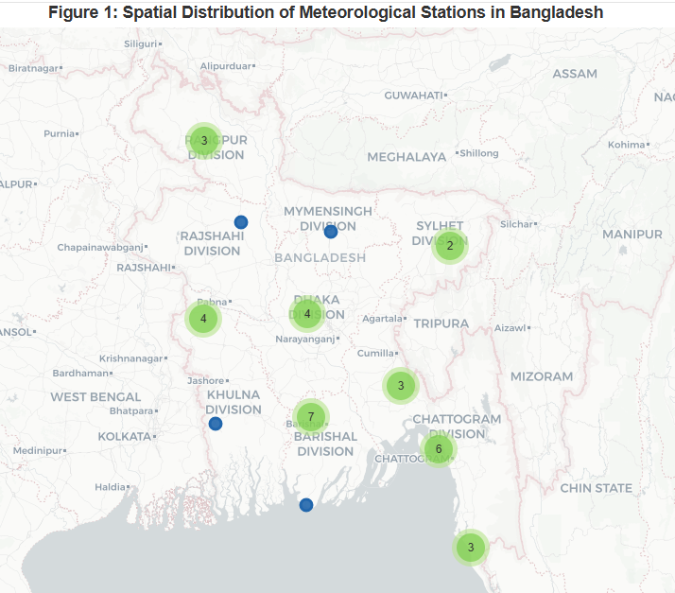
Figure 1. Map of Bangladesh showing the locations of the 36 stations used in this study (1983–2014).

3.2 Climatic Variables Used in the Analysis
Seven monthly meteorological variables were selected in order to represent the principal thermal, moisture, and atmospheric circulation characteristics governing Bangladesh’s annual climatic cycle: monthly total rainfall (mm), mean maximum temperature ($Tmax$, °C), mean minimum temperature ($Tmin$, °C), cloud cover (oktas), mean wind speed (m/s), mean relative humidity (%), and mean dry-bulb temperature (°C). These variables jointly represent the principal components of seasonal climate variability. The inclusion of these variables allows the seasonal classification to be determined from a multidimensional atmospheric perspective rather than from rainfall or temperature alone.
To examine the internal dependence structure among these variables prior to clustering, a Pearson correlation analysis was performed. Figure 2 shows the full Pearson correlation matrix (Hadd & Rodgers, 2021). The strongest pairings are $Tmin$with dry-bulb temperature (r = 0.92) and $Tmin$ with cloud cover (r = 0.86), both unsurprising given how closely night-time temperatures, cloud retention, and atmospheric moisture are linked during monsoon months. The correlation structure indicates strong associations among temperature and moisture-related variables, whereas wind speed remains comparatively weakly correlated with the rest, suggesting the presence of an independent atmospheric signal within the multivariate dataset.
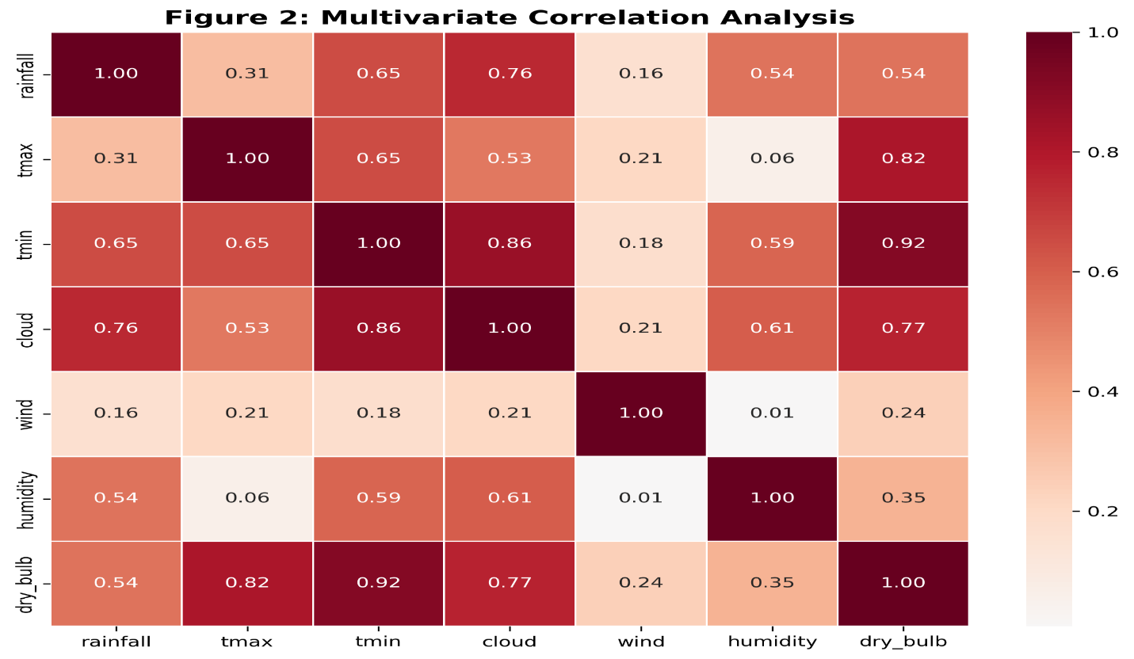
Figure 2. Pearson correlation matrix for the seven meteorological variables (1983–2014).

3.3 Missing Value Imputation
In meteorological datasets, missing observations are inevitable due to sensor malfunctions or reporting gaps. To maintain the continuity of the time-series for clustering, missing values were handled through a three-level hierarchical procedure that prioritizes climatological specificity. This approach preserves local station-specific seasonal structures before falling back on regional or national averages, ensuring consistency with standard climatological data-completion practice for long-term monthly normals (WMO, 2017).
The hierarchy was implemented as follows:
- Level 1 (Station-specific Month Mean): A missing observation was replaced by the long-term climatological mean (µ) for that specific variable ($v$) at the same station ($s$) for the corresponding month ($m$). For instance, a missing July rainfall record at Rajshahi was substituted with the mean of all available July rainfall observations at that station across the study period.
$${\hat{x}}_{v,s,m}=\frac{1}{N}\sum_{i∈Years}{x_{v,s,m,i}}$$
Where $\hat{x }$is the imputed value and $N$ is the number of years with available observations for that specific station-month.

- Level 2 (National Monthly Mean): Where a station had no observations at all for a given variable-month combination (e.g., a station newly established or with long-term gaps), the national monthly mean across all stations used as an alternative. This ensures the regional seasonal trend is maintained.
$$x_{vm}=\frac{1}{S}\sum_{s=1}^{S}{x_{vsm}}​$$
where $S$ denotes the total number of available stations.

- Level 3 (Global Mean): Any remaining isolated gaps were filled using the overall dataset mean for that variable:
$$\hat{x_{v}}=\frac{1}{M}\sum_{j=1}^{M}{x_{vj}}$$
where $M$ is the total number of non-missing observations for variable $v$.
This final step ensured a complete, gap-free matrix required for the K-Means clustering algorithm. After imputation, the dataset contained zero missing values across all 13,164 station-month records. The descriptive statistics of the processed dataset are summarized in Table 1.
Table 1. Descriptive Statistics of the Imputed Dataset (1983–2014; n = 13,164 station-months)
Variable | Mean | Std Dev | Min | Max
Rainfall (mm) | 201.84 | 241.15 | 0 | 3001
Tmax (°C) | 33.78 | 2.96 | 25.2 | 44
Tmin (°C) | 17.83 | 5.57 | 3 | 26.4
Cloud Cover (oktas) | 3.49 | 2.07 | 0 | 8
Wind Speed (m/s) | 3.51 | 1.58 | 0 | 16.6
Humidity (%) | 79.64 | 6.68 | 40 | 97
Dry-Bulb Temp (°C) | 25.52 | 3.85 | 13.2 | 32

3.4 Feature Importance
Before clustering, a Principal Component Analysis (PCA) was used on the completely standardized dataset of 13,164 station-months to approximate the relative importance of each variable to the overall seasonal variance structure (Jolliffe & Cadima, 2016). The importance of these features was quantified by calculating the Eigenvalues ($λ)$ and Eigenvectors of the covariance matrix. To address multicollinearity among the seven variables, PCA was used to transform the data into orthogonal components.
Following the approach of (Meraj & Shetty, 2023), the explained variance ratios of the principal components were examined to estimate the relative contribution of the underlying climatic dimensions within the dataset. This is represented by Eigenvalue decomposition:
$$Explained Variance Ratio =\frac{λ_{i}}{∑λ}$$
Variables associated with larger eigenvalue $(λ)$ contributions were interpreted as stronger discriminators of the national seasonal variance structure (Nie et al., 2021). Examination of eigenvector loadings further identifies which meteorological parameters exert the strongest influence on Bangladesh’s annual climatic cycle. This step ensures that the subsequent clustering structure is interpreted in relation to the dominant physical drivers of Bangladesh’s annual climatic variability rather than as a purely algorithmic partition.

3.5 Seasonal Clustering and Algorithm Validation
To objectively re-classify the annual climate cycle of Bangladesh, monthly climatological profiles were generated by averaging each meteorological variable for each calendar month across all 36 stations and the full 1983–2014 period. In this representation, each calendar month is treated as a composite multivariate climatic signature derived from the full 13,164 station-month observations.

3.5.1 Feature Standardization and Algorithm Selection
Since the variables in this study have different units (e.g., Rainfall in mm, Temperature in °C, Cloud cover in Oktas), they cannot be compared directly on their raw scales. Therefore, a Z-score Standardization was applied to ensure each feature contributes equally to the distance calculations:
$$Ζ=\frac{x-μ}{σ}$$
Where $x$ is the observed value, µ is the mean, and $σ$ is the standard deviation. This ensures a dimensionless and scale-invariant input for the clustering algorithms.
To be sure of the robustness of seasonal constraints, three distinct clustering techniques were evaluated: K-means, Gaussian mixture models (GMM), and hierarchical aggregate clustering (with ward linkage) (Das et al., 2024; Mahmud et al., 2022).
The primary classification relied on the K-Means objective function, which minimizes the within-cluster sum of squares (WCSS):
$$J=\sum_{j=1}^{k}{\sum_{i=1}^{n_{j}}{{||\left(x_{ij}-μ_{j}\right)||}^{2}}}$$
Where$k$ represents the number of clusters, and $μ_{j}$ is the centroid of cluster $c_{j}$.

3.5.2 Model Validation
The most appropriate number of clusters $k$ and the performance of each set of rules were rigorously tested for $k=2$to $k=7$ using three distinct internal validation metrics. This multi-metric approach ensures that the resulting seasonal classification is statistically robust and not an artifact of a single mathematical objective.
- Silhouette Score ($S)$: This metric measures the mean intra-cluster distance ($a$) and the mean nearest-cluster distance ($b$) for each sample. It is calculated as:
$$S=\frac{b-a}{max⁡(a,b)}$$
A higher $S$ (closer to 1) indicates well-defined clusters (Rousseeuw, 1987).
- Davies-Bouldin Index $(DB)$: This index Evaluates the proportion of within-cluster dispersion and between-cluster segregation.

$$DB =\frac{1}{k}\sum_{i=1}^{k}{max_{j≠i}\left(\frac{\left(s_{i}+ s_{j}\right)}{\left(d_{ij}\right)}\right)}$$
Where $s$ is cluster scatter and $d$is the distance between centroids.
The intention is to minimize $DB$ index to achieve maximum cluster separation(Davies & Bouldin, 1979).

- Calinski-Harabasz Index $(CH)$: Also known as the Variance Ratio Criterion, it is the ratio of the sum of between-clusters dispersion to within-cluster dispersion.

$$CH =\frac{SS_{B}}{SS_{W}}×\frac{N - k}{k - 1}$$

Higher values of ($CH)$ indicate dense and well-separated clusters (Calinski & Harabasz, 1974).
By triangulating these three indices, the study ensured the stability of the identified seasonal boundaries across the 32-year study period.

3.5.3 Statistical Validation and Significance Testing
To determine whether the detected seasonal restructuring reflected statistically meaningful climatic change rather than random clustering variation, several inferential procedures were employed.
- Mann-Whitney U Test: A non-parametric Mann-Whitney U test was applied to check whether there were significant differences in the distribution of climatic parameters (e.g., rainfall, temperature) between the early (1983-1993) and recent (2005-2014) decades. It was preferred to the t-test due to the non-normality of some meteorological variables.
The Mann-Whitney U statistic was calculated as:
$$U = n_{1}n_{2}+\frac{n_{1}\left(n_{1}+ 1\right)}{2}– R_{1}$$
Where $n_{1},n_{2}$ are the sample sizes of the two decades being compared. $R_{1}$ is the sum of ranks for the first decade.

- Permutation Testing: To determine if the cluster reassignments (seasonal shifts) were statistically significant, a permutation test with 2,000 iterations was conducted. It involved permuting the years to create a reference null distribution of seasonal reassignments. The statistical significance was evaluated by calculating the permutation p-value:

$$p =\frac{1 + \sum_{i=1}^{N}{I\left(S_{i}≥S_{obs}\right)}}{1 + N}$$
Where $S_{obs}$ is the number of month-to-month cluster shifts from Decade 1 to Decade 3. $S_{i}$ is the number of shifts in the $i$-th permutation. $I(.)$ is the indicator function, which equals 1 if the condition $\left(S_{i}≥S_{obs}\right)$ is met, and 0 otherwise.
- Bootstrap Confidence Intervals: To assess the accuracy of the Dynamic Time Warping (DTW) distances, a station-based bootstrapping (B=1000) was carried out. This enabled the calculation of 95% confidence intervals (CI) to verify whether the shift in the restructuring of the seasons between decades was significant.
$$CI_{95\backslash \%}= \left[ θ_{2.5}^{*}, θ_{97.5}^{*}\right]$$

Where $θ^{*}$ is the distribution of the DTW distance with B=1000 resampled data sets. Non-overlapping confidence intervals were later used as supporting evidence of differential temporal restructuring between decade pairs.

- Chi-square Test of Independence: We used this test to assess whether the proportion of months assigned to different seasonal clusters differed between the periods. The statistic is calculated as:

$$χ^{2}= \sum_{i}{\frac{{\left(O_{i}- E_{i}\right)}^{2}}{E_{i}}}$$
where $O_{i}$ is the observed count of months in a season for a specific decade, and $E_{i}$ is the expected count under the null hypothesis.

3.6 Multidecadal Phase Change Analysis
The analysis of the pattern of temporal changes in the seasons was performed by dividing the 32-year study period into three climatological sub-periods: Decade 1 (1983-1993), Decade 2 (1994-2004), and Decade 3 (2005-2014). For each decade, monthly national climate profiles were independently computed from the seven standardized meteorological variables. K-Means clustering using the previously validated optimal cluster number was then applied to each decade’s profile to determine the seasonal identity of each month within that specific period.

3.6.1 Dynamic Time Warping for Temporal Seasonal Comparison
Conventional month-to-month Euclidean comparison assumes strict temporal alignment and therefore tends to exaggerate dissimilarity when seasonal peaks shift slightly forward or backward in the calendar. Dynamic Time Warping (DTW) overcomes this limitation by permitting non-linear temporal alignment between two climatological sequences, thereby capturing delayed or advanced onset and withdrawal of seasonal regimes (Laperre et al., 2020; Virdee et al., 2023). DTW was applied on standardized climatological profiles to compare relative seasonal patterns across decades. This permits identification of structural seasonal similarity even when rainfall, humidity, or temperature maxima occur earlier or later than in previous decades. Thus, the distances reflect structural differences rather than absolute magnitude changes.

3.6.2 Mathematical Framework
The dissimilarity was computed by building the optimal warping path between the decadal sequences. For two decadal climate sequences $Q=\{q1,q2,...,qn\}$ and $C=\{c1,c2,...,cm\}$ the cumulative DTW distance was calculated recursively as:
$$D\left(i,j\right)=d\left(q_{i},c_{j}\right)+min \{ D\left(i-1,j\right), D\left(i,j-1\right), D\left(i-1,j-1\right)\}$$
Where $d\left(q_{i},c_{j}\right)$ represents the Euclidean distance between the climatic feature vectors of month $i$ and month $j$.
To make the distance comparable with different time scales, it was normalized by the length of the warping path K:
$$DTW_{normalized}=\frac{D\left(n, m\right)}{K}$$
This normalization allows the distance to be interpreted as the average dissimilarity per month between the two climatic cycles.

3.6.3 Phase Shift Detection
A seasonal phase shift was defined as a month whose cluster membership changed between Decade 1 and Decade 3. It means that there is a fundamental shift in the climatic nature of that month, implying that traditional seasonal boundaries are no longer consistent with contemporary meteorological patterns. These monthwise transitions provide the empirical basis for identifying the contemporary displacement of Bangladesh’s traditional seasonal boundaries, later summarized in Figure 12.

4. RESULTS

4.1 Importance of Climatic Features
Principal Component Analysis (PCA), described in 0, was used to identify the dominant drivers of seasonal variability within the seven-variable climatic dataset (Jolliffe & Cadima, 2016). The results, summarized in Figure 3, show that the first three principal components explain 88.75% of the total variance, with rainfall emerging as the dominant contributor. This confirms the dominant influence of monsoon hydroclimatic forcing and thermal seasonality in shaping Bangladesh’s annual climate cycle (Turner & Annamalai, 2012). Interestingly, even though there is a strong correlation with minimum temperature ($T_{min⁡}$) $(r=0.92)$, dry-bulb temperature contributes very little ($<$1%) to seasonal differences, suggesting it is nearly redundant when other thermal variables are included.
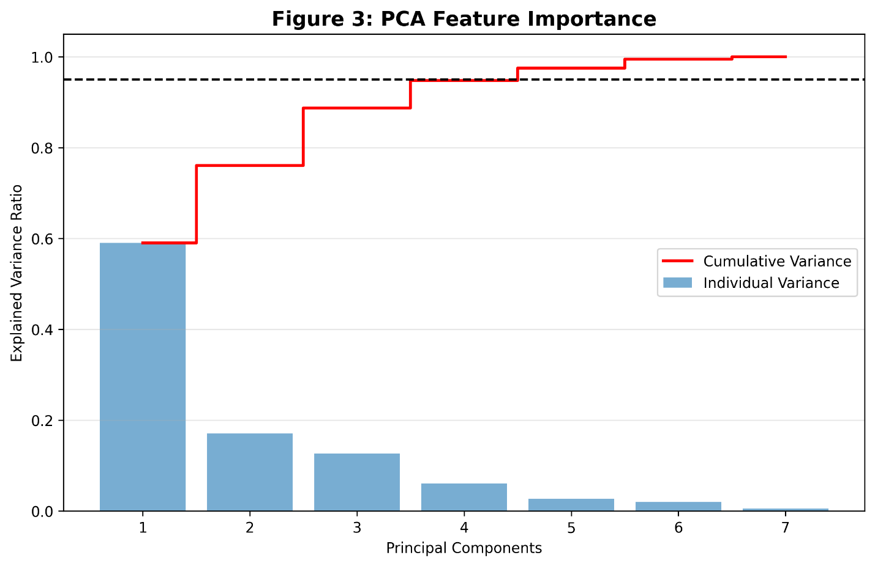
Figure 3. PCA variance explanation that demonstrates the importance of rainfall and thermal variables.

4.2 Monthly Climate Profiles and Heatmap Analysis
Figure 4 illustrates the average monthly climatological behavior of the seven variables, with bar colors indicating their corresponding K-Means cluster membership $(k = 4).$ The hydrological profile indicates that the rainfall has an annual minimum in the months of December and January, rises gradually through the pre-monsoon months, and reaches a pronounced peak during the monsoon months (June–July). At the same time, the thermal profile shows that the maximum temperature reaches its annual maximum in April during the pre-monsoon heat buildup, before declining slightly during the monsoon as the cloud cover increases and the cooling of the air by evaporation occurs, a behavior which is similar to the results of solar radiation variability reported by (Wang et al., 2012).

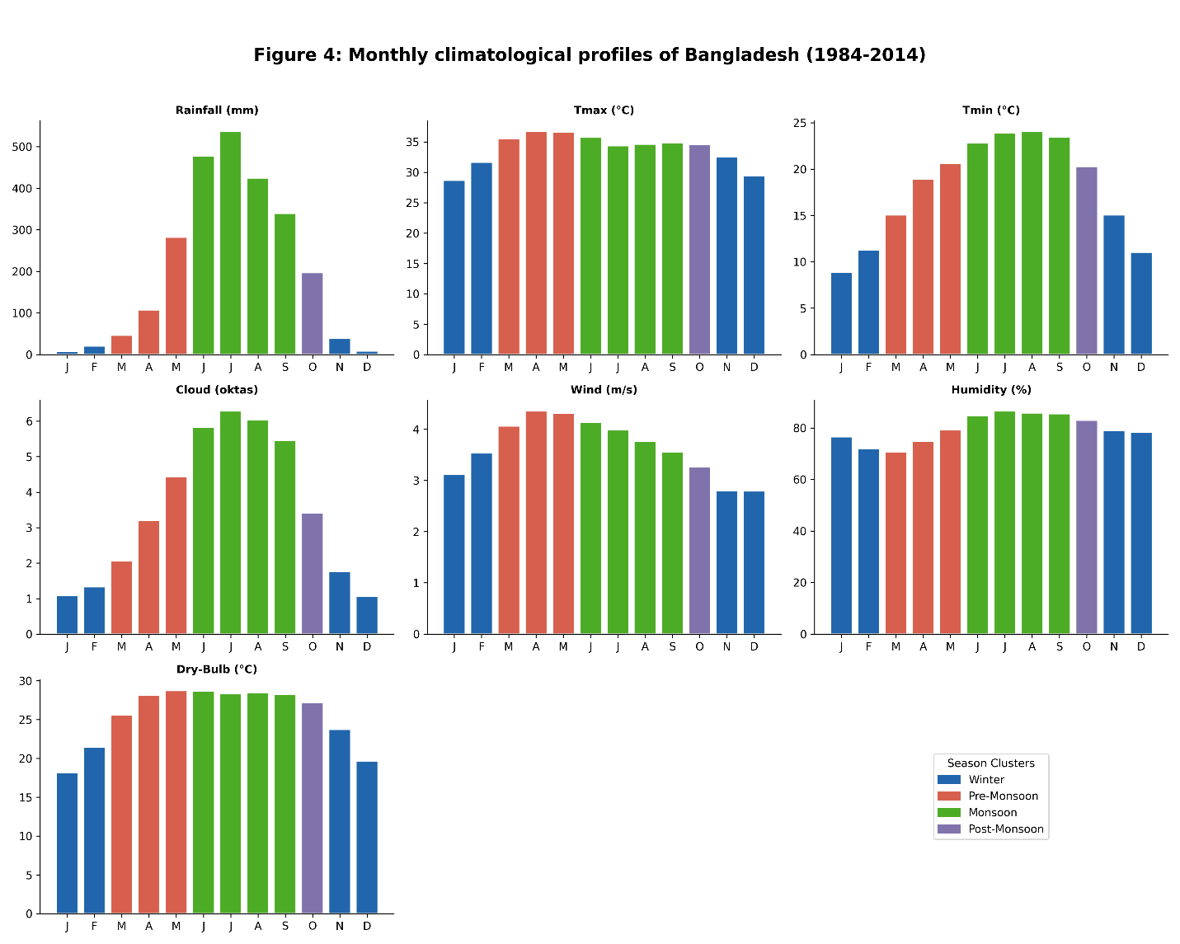
Figure 4. Averages of the monthly climatological data (1983-2014) with cluster-coded bar colors.

The standardized heatmap in Figure 5 further supports these monthly climatic transitions, as it reveals the correspondence of climatic variables. The results show a high-intensity Z-score similarity between rainfall, humidity and cloud cover during June to September which objectively explains their inclusion in one cluster, justifying their aggregation into the Monsoon cluster. Conversely, during the winter months, there is a high negative Z-score synchronization of moisture-related variables. The marked shift in color schemes in the heatmap during April and October indicates the clear delimiting lines of the pre-monsoon and post-monsoon seasons, providing objective support for the four-season framework identified by the clustering analysis.
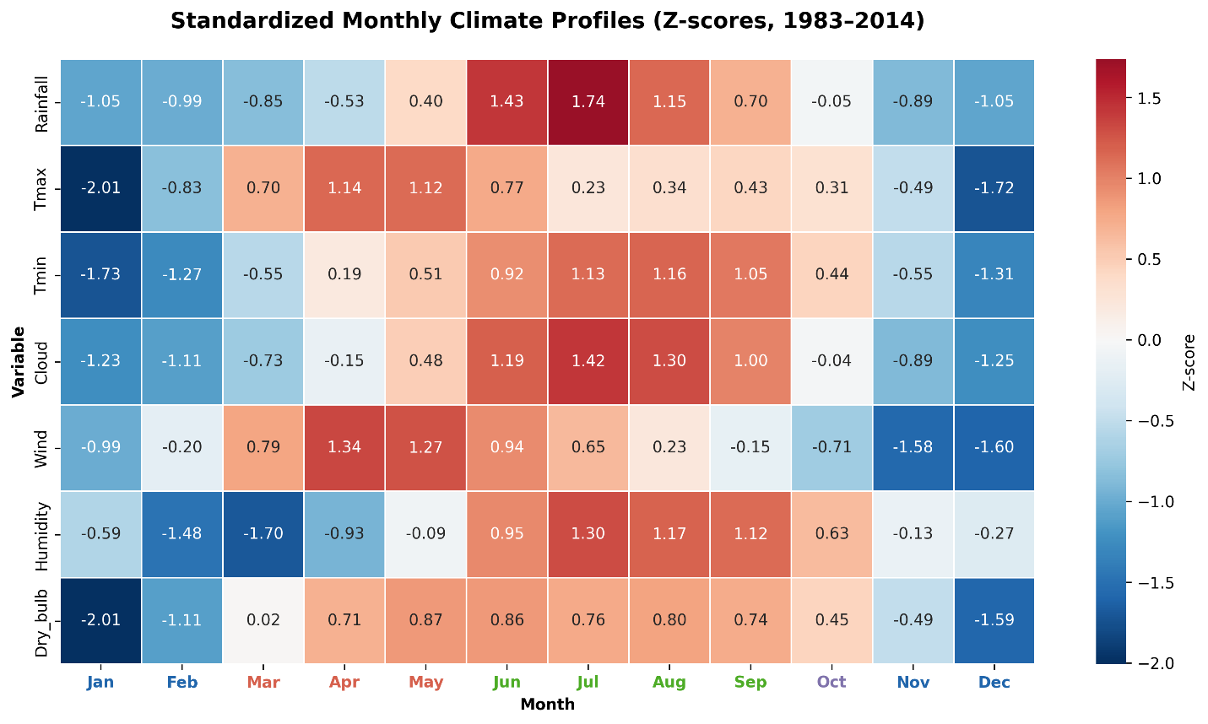
Figure 5. Z-score heatmap of climatic variables synchronization of seasons.

4.3 Cluster Validation and Algorithm Comparison
Three validation metrics were evaluated for $(k=2$ to 7) to determine the statistically optimal seasonal partition. As illustrated in Figure 6, all three validation indices consistently converge on an optimal solution at k = 4. For this four-cluster configuration, the Silhouette Score (0.384), Davies-Bouldin Index (0.517), and Calinski-Harabasz Index (16.385) collectively indicate that the four-cluster configuration provides the most stable balance between within-cluster cohesion and between-cluster separation. Although the absolute Silhouette value is moderate, such values are common in climatological datasets where seasonal boundaries are transitional rather than sharply discrete. More importantly, all three independent indices converged consistently at k = 4, while higher k values produced fragmented boundary months without meaningful climatological interpretability. Therefore, k = 4 was retained as the most parsimonious and physically coherent solution.
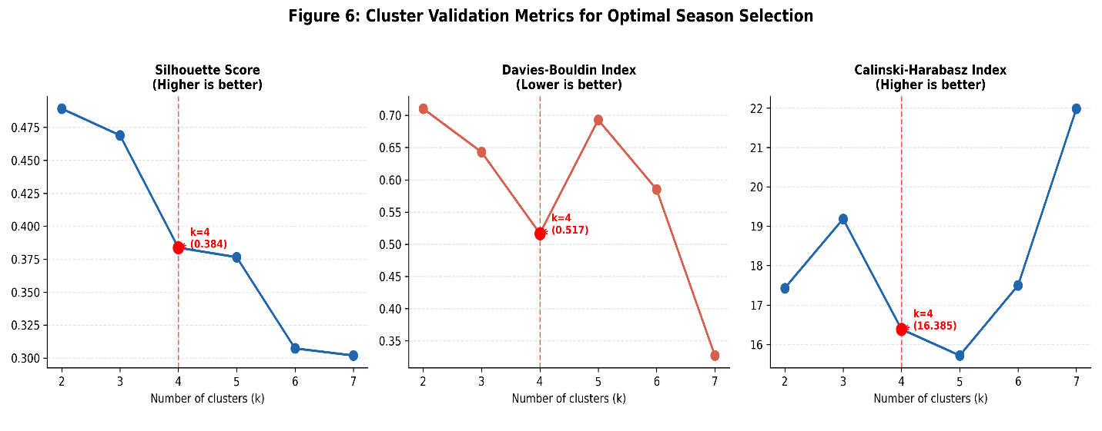
Figure 6. Internal validation indices identifying the optimal four-cluster solution.
A direct comparison in Table 2 shows that K-Means and Hierarchical Agglomerative Clustering (HAC) both outperformed Gaussian Mixture Models (GMM) across all performance metrics. Notably, K-Means and HAC yielded identical validation scores, demonstrating a strong consensus in the seasonal partition regardless of clustering strategy. This finding is consistent with previous environmental clustering studies in which centroid-based and hierarchical methods often produce stable solutions for low-dimensional climatological datasets (Laperre et al., 2020).

Table 2. Comparative Performance of K-Means, Gaussian Mixture Model, and Hierarchical Agglomerative Clustering..
Algorithm | Silhouette Score ↑ | Davies–Bouldin Index ↓ | Calinski–Harabasz Index ↑
K-Means | 0.384 | 0.517 | 16.385
GMM | 0.351 | 0.532 | 14.861
Hierarchical (HAC) | 0.384 | 0.517 | 16.385

Furthermore, the hierarchical dendrogram Figure 7 produces a clustering structure consistent with the K-Means solution, showing two major super-clusters (dry and wet) that divide neatly into four seasonal classes at a linkage distance of approximately 2.53.
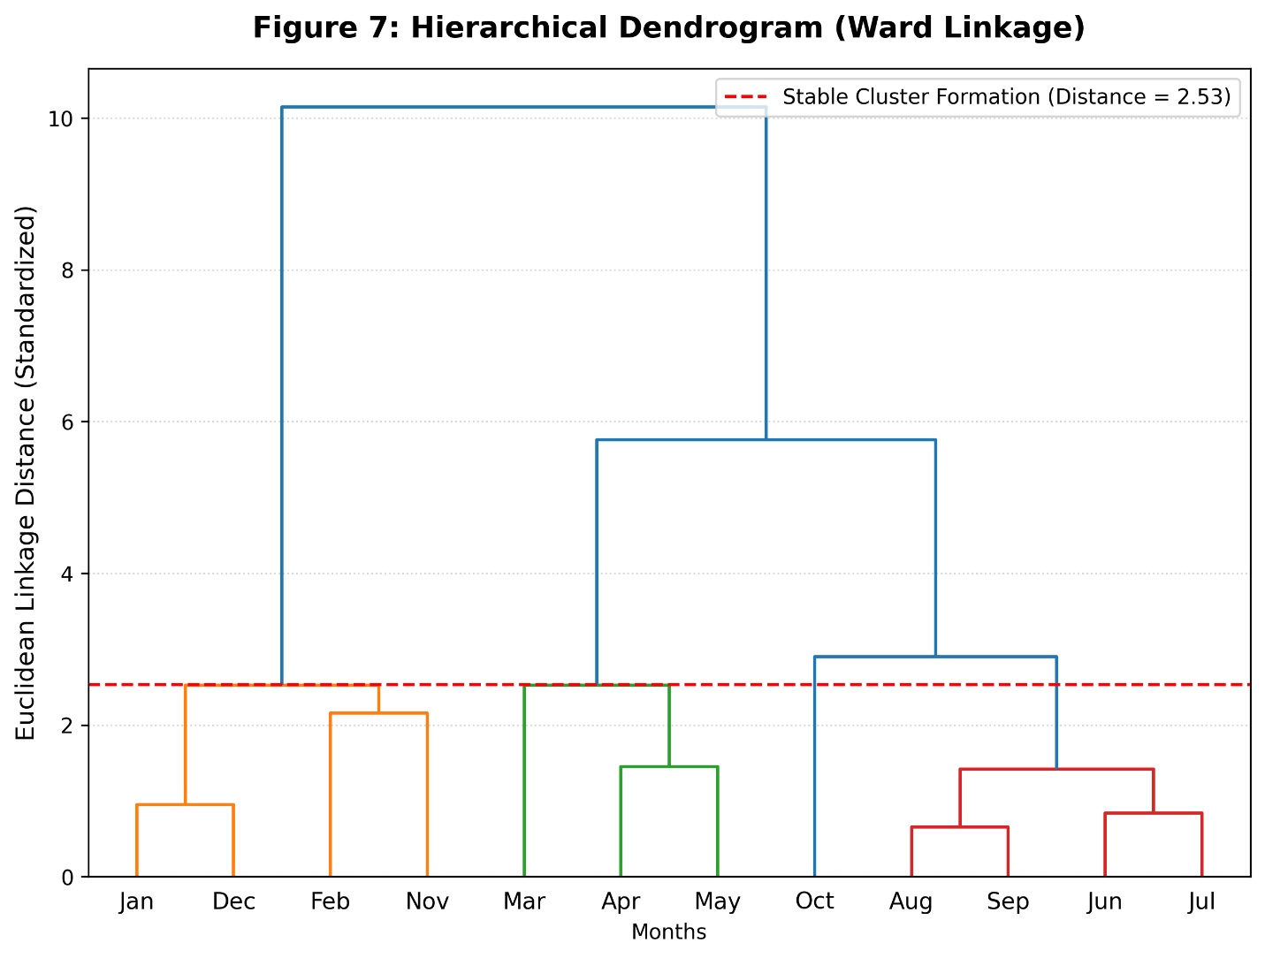
Figure 7. Hierarchical dendrogram (Ward linkage) that supports the four-cluster structure.

4.4 Empirical Seasonal Classification
The final seasonal classification derived from the optimized K-Means solution (k = 4) is presented in Table 3. Winter (January, February, November, December) is identified as the coolest and driest season, with a mean dry-bulb temperature of $20.707 °C$ and minimal rainfall. The Pre-Monsoon (March-May) represents the hottest phase of the year, characterized by the maximum temperature of $36.325 °C$ and the lowest humidity of the year at 74.838 %. The Monsoon season (June-September) forms the dominant wet regime, receiving an average monthly rainfall of 431.134 mm. Finally, the Post-Monsoon (October) acts as a transitional period where rainfall decreases but still averages 194.681 mm per month.
In this context, November requires special consideration. In our 32-year optimized model, November is reassigned from its traditional transition state to the Winter group. This reassignment is driven by significantly lower minimum temperature (11.373 °C) and sharply reduced rainfall, which together produce stronger multivariate similarity with the established winter months than with the residual post-monsoon phase. This inclusion indicates a substantial expansion of the winter regime in Bangladesh, suggesting that the traditional seasonal boundary of the Hemanta season (often spanning November–December) has lost its internal consistency under the current climatic regime. This observed instability suggests a measurable reorganization within the annual climatic cycle under recent climatic variability (Stine et al., 2009).
Table 3. Empirical Seasonal Characteristics based on K-Means Clustering (1983–2014)
Season | Rainfall (mm) | $Tmax$ (°C) | $Tmin$ (°C) | Cloud (okta) | Wind (m/s) | Humidity (%) | Dry bulb (°C) | Months
Winter | 18.726 | 30.54 | 11.373 | 1.312 | 2.934 | 76.499 | 20.707 | Jan, Feb, Nov, Dec
Pre-Monsoon | 143.08 | 36.325 | 18.08 | 3.243 | 4.116 | 74.838 | 27.474 | Mar, Apr, May
Monsoon | 431.134 | 34.923 | 23.533 | 5.878 | 3.724 | 85.566 | 28.457 | Jun, Jul, Aug, Sep
Post-Monsoon | 194.681 | 34.557 | 20.158 | 3.396 | 3.157 | 82.969 | 27.158 | Oct

4.5 Rainfall Distribution and the Post-Monsoon Cluster
The assignment of October to the Post-Monsoon cluster represents a substantial departure from traditional calendars that frequently treat it as the start of the dry season. This classification is empirically justified by the rainfall probability density functions (PDFs) illustrated in Figure 8. The October rainfall distribution lies substantially closer to the July monsoon peak distribution than to the January winter distribution. In particular, its long right-skewed tail extending well beyond 400 mm weakens the climatological basis for classifying October as a dry month. This high dispersion and comparatively high mean rainfall (194.681 mm) supports its interpretation as a distinct transitional group with residual monsoon characteristics.
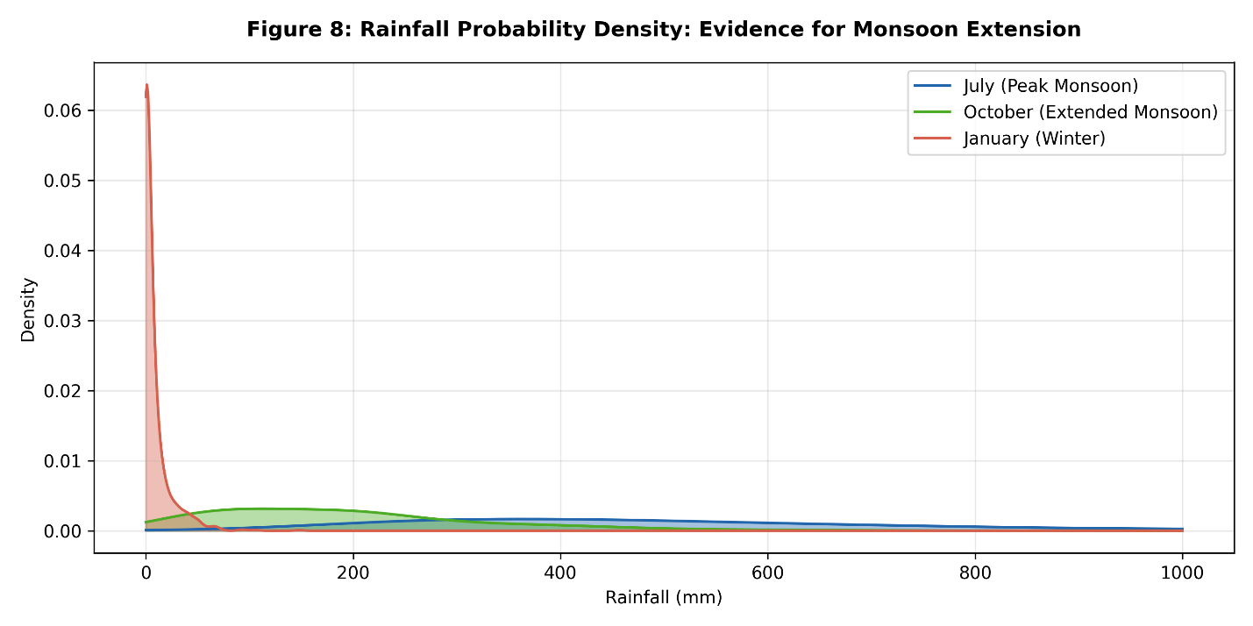
Figure 8. July, October and January Rainfall PDFs.

4.6 Multi-Decadal Changes and Phase Shifts
The multi-decadal comparison shows that there is progressive reorganization of the timing of the annual climatic regime in Bangladesh. Figure 9 shows that the climatological profiles of the three decades exhibit apparent deviation in a number of key meteorological variables, but the greatest deviations are observed in the transitional months. Although the main monsoon months can be generally identified, the integration of intense rainfall, a prolonged humidity, and slower wind speed all suggest less consistency in the seasonal advancement between Decade 1 (1983-1993) and Decade 3 (2005-2014).
The Dynamic Time Warping (DTW) results in Table 4, provide quantitative evidence of increasing temporal dissimilarity among the decadal seasonal profiles. The normalized DTW distance between Decades 1 and 2 was 0.473923 and between Decades 2 and 3 was 0.904189 and a total dissimilarity of 1.245992 between Decade 1 and Decade 3. This pattern indicates that the recent climatic cycle has diverged more strongly from its historical baseline than the earlier intermediate period (Teke & Çetin, 2021).
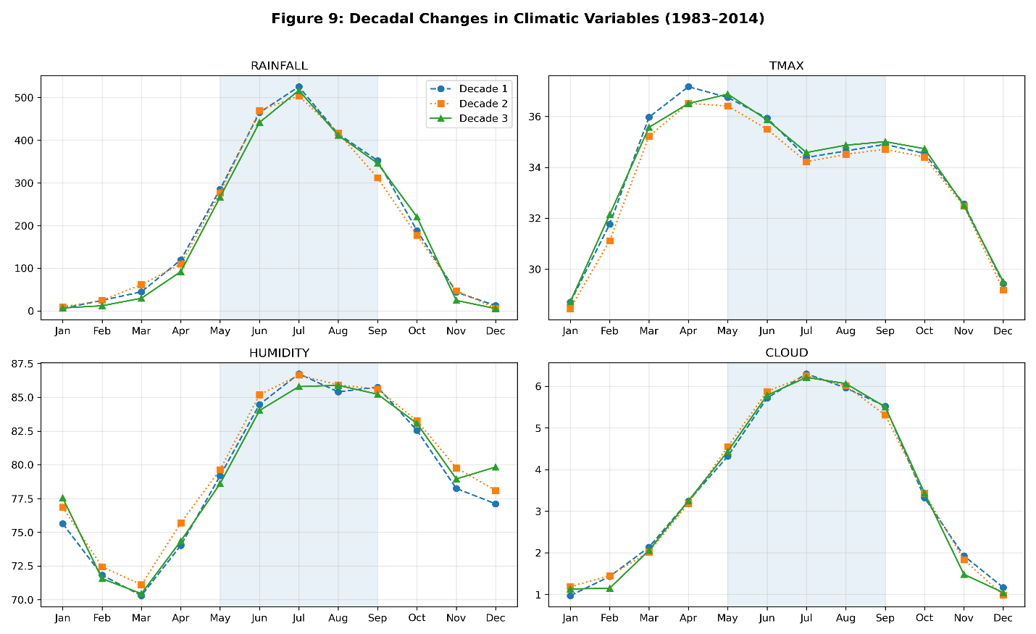
Figure 9. Decadal climatological profiles showing multi-variable seasonal divergence.

Table 4. Dynamic Time Warping Distances among Three Climatic Decades.
Comparison | DTW Distance
Decade 1 (1983–93) vs. Decade 2 (1994–2004) | 0.473923
Decade 2 (1994–2004) vs. Decade 3 (2005–2014) | 0.904189
Overall: Decade 1 vs. Decade 3 | 1.245992
A decomposition of the overall DTW distances (Figure 10) also helps to explain what climatic factors play the major roles in this decadal shift. The total DTW displacement is the greatest for wind speed, followed by rainfall and humidity among the seven meteorological variables. This suggests that although wind speed was not the primary driver in static seasonal clustering, its shifting cycle validated by a large effect size in the Mann-Whitney test $(r = 0.31, p < 0.001)$- indicates high sensitivity to climate variability. Rainfall and humidity also have significantly larger deviations during the second decade (D2 vs. D3), confirming the observed persistence and delayed retreat of the monsoon-like conditions in recent decades.
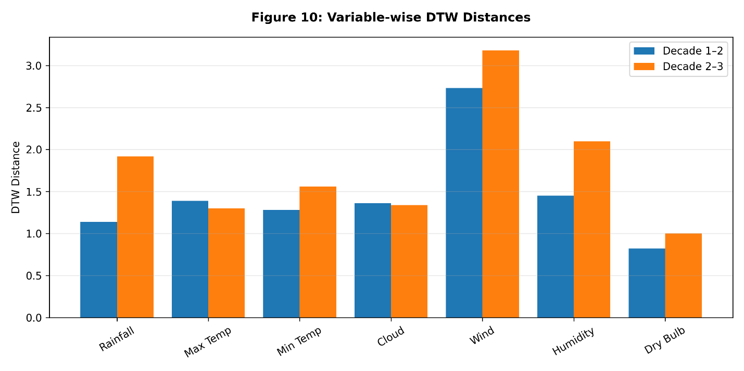
Figure 10. Variable-wise DTW distances.

In order to statistically support the visual decadal differences shown in Figure 9 and Figure 10, the mean values of the seven meteorological elements were compared across the three decades Table 5).

Table 5. Decadal Variable Means and Significance
Variable | D1 Mean | D2 Mean | D3 Mean | ∆ (D3-D1) | p-val | Sig
Rainfall (mm) | 206.52 | 201.23 | 197.86 | -8.66 | 0.0002 | ***
Tmax (°C) | 33.9 | 33.56 | 33.91 | 0.01 | 0.2137 | ns
Tmin (°C) | 17.71 | 17.85 | 17.94 | 0.22 | 0.0002 | ***
Cloud (okta) | 3.5 | 3.51 | 3.46 | -0.04 | 0.2335 | ns
Wind (m/s) | 3.86 | 3.62 | 3.06 | -0.8 | 0 | ***
Humidity (%) | 79.26 | 80.02 | 79.61 | 0.34 | 0.2227 | ns
Dry-bulb (°C) | 25.53 | 25.44 | 25.59 | 0.06 | 0 | ***

The decadal mean comparison confirms that several climatic elements have shifted significantly over time. The results show highly significant (p < 0.001) shifts in Rainfall, Minimum Temperature, and Wind Speed. Although absolute maximum temperature $(Tmax)$ remained unchanged $(ns),$ an increase in minimum temperature $(Tmin)$ indicates a contraction in the diurnal temperature range and a warming of minimum temperatures. The most pronounced absolute shift is observed in wind speed, which decreased by $0.8 m/s$ between Decade 1 and Decade 3, reinforcing its strong contribution to the observed temporal displacement of seasonal boundaries.
The actual boundary relocation of seasonal identities becomes clearer in Table 6, and Figure 11-Figure 12. Table 6. Decadal Boundary Reallocation of Seasonal Months summarizes the month-level reassignment of seasonal categories between Decade 1 and Decade 3 and shows that four transitional months (March, April, October, and November) exhibited reassignment in seasonal affiliation.
Table 6. Decadal Boundary Reallocation of Seasonal Months
Boundary Component | Decade 1 | Decade 3 | Interpretation
Winter Duration | Jan, Feb, Dec | Jan, Nov, Dec | Winter shifted
Pre-Monsoon Duration | Jun, Jul, Aug, Sep | Jun, Jul, Aug, Sep | unchanged
Monsoon Duration | Oct, Nov | Feb, Mar | Monsoon shifted
Post-Monsoon Duration | Mar, Apr, May | Apr, May, Oct | Post-Monsoon shifted
Mar Boundary | Post-Monsoon | Monsoon | Mar boundary shifted from Post-Monsoon to Monsoon
Apr Boundary | Post-Monsoon | Post-Monsoon | Apr boundary unchanged
Oct Boundary | Monsoon | Post-Monsoon | Oct boundary shifted from Monsoon to Post-Monsoon
Nov Boundary | Pre-Monsoon | Winter | Earlier winter intrusion
This month-wise redistribution reveals that between Decade 1 and Decade 3, 4 out of 12 months (33.3% of the year) changed their cluster assignments, as specifically marked by the "Shift" indicators in Figure 12. This reflects the increasing variability in the onset and duration of seasonal patterns in South Asia(Stine et al., 2009; Turner & Annamalai, 2012). Crucially, the "core" Winter and Monsoon months have not changed, while the most dynamic change has been observed in the boundary months. Both March and April, previously identified as Pre-Monsoon, now exhibit Post-Monsoon-like features, implying a less effective early monsoon build-up. On the other hand, October transitions from Post-Monsoon to Pre-Monsoon, suggesting a delay in the monsoon retreat, and November takes on more Winter-like characteristics.
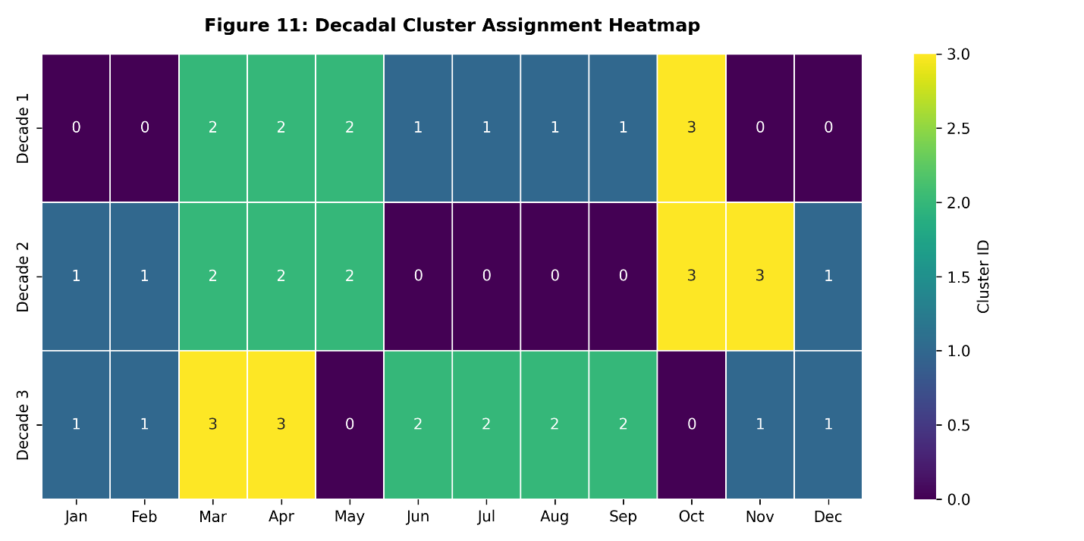
Figure 11. Heatmap of decadal cluster assignment.

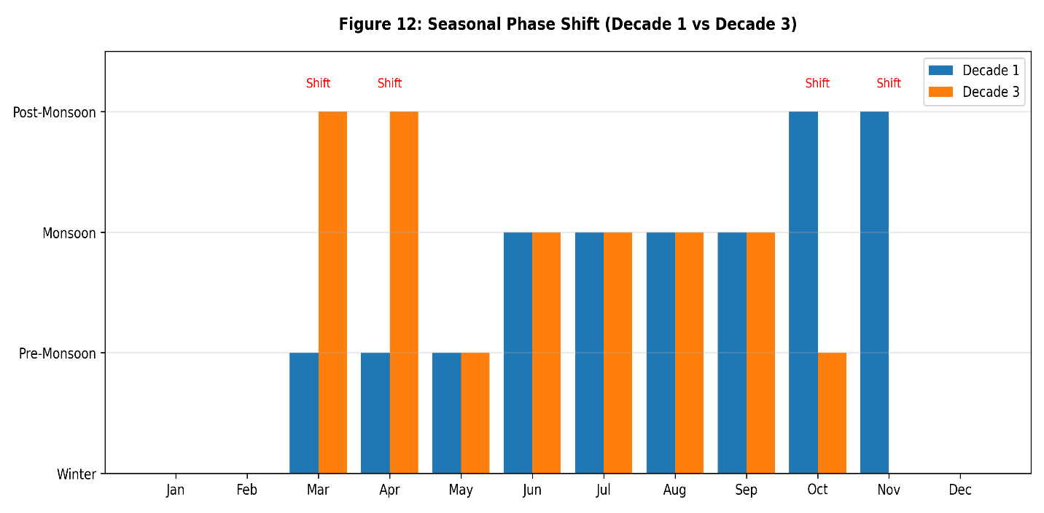
Figure 12. Phase shift analysis (Decade 1 vs. Decade 3) month-wise.

Figure 11and Figure 12 together show this phase shift by specifying the months of the year where the label of the seasons differ. Thus, the observed change is not a loss of seasons but a gradual shift in the seasons.

4.6.1 Statistical Assessment of Temporal Seasonal Reclassification

To evaluate whether the observed decadal climatic differences and month-wise seasonal redistributions are supported by inferential evidence, four complementary statistical procedures were applied for validation: the Mann-Whitney U test, Bootstrap Confidence Interval (BCI) estimation of the DTW distances, a permutation-based cluster reassignment test, and the Chi-square test of seasonal frequency stability. The summary results in Table 7 indicate that the temporal reorganization is strongly supported at the variable level, while the month-count of reassignment is more suggestive than independently conclusive.

4.6.2 Variable-wise Analysis (Mann-Whitney U Test)

The Mann-Whitney U test was used to compare the distribution of climate variables between Decade 1 (1983-1993) and Decade 3 (2005-2014). The results of this test showed that four of the seven variables showed significant changes (p < 0.05). Significantly, Rainfall (p=0.0002), Minimum Temperature (p=0.0001), and Dry-bulb Temperature (p < 0.0001) all displayed long-term changes. Wind Speed showed the largest effect size (r=0.325, p<0.001), suggesting a significant decrease in the average wind speed over this period, which is likely to have an impact on the perception and onset of seasonal transitions.

4.6.3 Validation of Seasonal Acceleration (Bootstrap CI)

A critical finding of this study is the acceleration of seasonal shifts, validated through Bootstrap Confidence Intervals (B=1000). The Dynamic Time Warping (DTW) distance, which quantifies the distance between decadal annual cycles, revealed that the shift from Decade 2 to Decade 3 (1.06, CI: [0.8076, 1.3599]) is much larger than the shift from Decade 1 to Decade 2 (0.47, CI:[0.322, 0.7826]). Given the non-overlapping 95% confidence intervals, indicate substantially greater temporal restructuring in the later decades, suggesting that the pace of seasonal divergence has intensified in the recent climatic period.

4.6.4 Cluster Stability and Frequency Distribution

A permutation test (N = 2000) was used to evaluate whether the observed four-month cluster reassignment exceeded that expected under random temporal redistribution. The resulting p-value of the permutation $(0.3635)$ shows that the number of months of reassignment by itself is not significantly out of line with the chance of occurrence. Nevertheless, the physical identity of the shifted months, especially the months of October and November, are climatologically relevant when explained in the context of the considerable decadal alterations in rainfall, Tmin, dry-bulb temperature, and wind speed. Moreover, the Chi-square test $( χ^{2} = 0.00, p = 1)$ is used to prove that the number of months in each seasonal cluster is the same, which proves that the prevailing process is the boundary displacement, but not loss and appearance of seasonal regimes.
Table 7. Summary of Statistical Significance Tests for Decadal Climate Shifts.
Test | Variable / Metric | Statistic | p-value | Significant $(α= 0.05)$ | Effect / Notes
Permutation test (N=2000) | Cluster shift count (D1 vs D3) | 4/12 months shifted | 0.3635 | No | Mean permuted = 2.6 months
Mann-Whitney U (D1 vs D3) | rainfall | U = 9449824.5 | 0.000207 | Yes | r = 0.0464 (Small); D1 > D3
Mann-Whitney U (D1 vs D3) | $$tmax$$ | U = 8890359.0 | 0.213665 | No | r = 0.0156 (Small); D3 > D1
Mann-Whitney U (D1 vs D3) | $$tmin$$ | U = 8610309.0 | 0.0002 | Yes | r = 0.0466 (Small); D3 > D1
Mann-Whitney U (D1 vs D3) | cloud | U = 9164702.0 | 0.233493 | No | r = 0.0148 (Small); D1 > D3
Mann-Whitney U (D1 vs D3) | wind | U = 11967231.0 | < 0.001 | Yes | r = 0.3251 (Large); D1 > D3
Mann-Whitney U (D1 vs D3) | humidity | U = 8893197.5 | 0.222704 | No | r = 0.0153 (Small); D3 > D1
Mann-Whitney U (D1 vs D3) | Dry-bulb | U = 8522424.0 | 7.00E-06 | Yes | r = 0.0563 (Small); D3 > D1
Bootstrap CI (B=1000) | Decade 1 vs Decade 2 | DTW = 0.473923 | N/A | N/A | 95% CI [0.322, 0.7826]
Bootstrap CI (B=1000) | Decade 2 vs Decade 3 | DTW = 1.057412 | N/A | N/A | 95% CI [0.8076, 1.3599]
Bootstrap CI (B=1000) | Decade 1 vs Decade 3 | DTW = 1.245992 | N/A | N/A | 95% CI [0.9309, 1.5609]
Chi-square | Season frequency (D1 vs D3) | $χ^{2}$= 0.0000, df = 3 | 1 | No | Season-months count contingency table

4.7 Spatial Variation
The spatial distribution of seasonal cluster assignments across the 36 meteorological stations reveals clear regional heterogeneity in Bangladesh’s climatic calendar Figure 13. The Monsoon (June–September) and Winter (November–February) clusters remain relatively more nationally coherent, whereas the strongest spatial departures are found during the transition periods of February-May and October-November.
Coastal and southeastern stations (e.g., Cox’s Bazar, Teknaf, Sandwip, and Hatiya) exhibit prolonged monsoon-like characteristics with high moisture and thermal indicators extending into October (and in a few cases, November). Such persistence is related to the fact that the strong maritime influence of the Bay of Bengal, and helps to soften seasonal cooling and maintain the humidity of the atmosphere. By contrast, the northern inland stations (e.g. Rajshahi, Dinajpur, and Rangpur) experience a shorter period of monsoon persistence and stronger pre-monsoon warming peak in March-April as they have a more continental inland location and weaker maritime moderation.
Figure 13 therefore demonstrates that the onset, persistence, and withdrawal of transitional seasonal regimes are not spatially synchronous across Bangladesh. While the core wet and cool seasons remain broadly stable, the boundary months exhibit substantial geographic displacement, indicating that the national seasonal cycle is climatically non-uniform across physiographic regions.
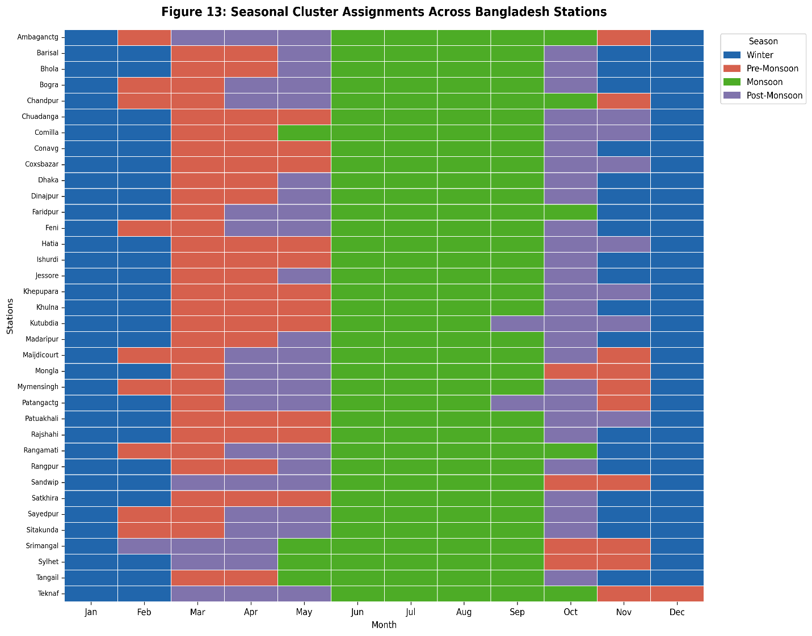
Figure 13. Seasonal cluster assignments of the stations of Bangladesh.

5. DISCUSSION

5.1 Reconsideration of the Traditional Seasonal Calendar
The four-cluster seasonal arrangement comprising Winter, Pre-Monsoon, Monsoon and Post-Monsoon represents a substantial departure from the traditional six-season (Shoro-Ritu) framework commonly described in historical and geographical accounts of Bangladesh (Banglapedia, 2021). The present results indicate that the traditionally recognized Sharat (Autumn) and Hemanta (Late Autumn) seasons no longer emerge as statistically separable climatic entities under a multivariate meteorological classification (Ahmed & Alam, 1999).
A particularly important outcome is the reassignment of November from its conventional transitional role into the Winter cluster. This shift is associated with markedly lower minimum temperatures (11.373 °C) and minimal rainfall (18.726 mm), suggesting an expansion of winter-like climatic conditions into the late autumn boundary. In contrast, October remains the sole representative of the Post-Monsoon cluster, characterized by high residual humidity (82.969%) and substantial rainfall (194.681 mm), which are more consistent with residual monsoon withdrawal than with a dry autumnal regime. Furthermore, the absence of a distinct Basanta (Spring) is evident as February remains firmly in the Winter group, while March has shifted towards Pre-Monsoon characteristics. The Pre-Monsoon phase is now defined by an abrupt surge in maximum temperatures (36.325 °C) and the lowest annual humidity (74.838%). Collectively, these findings suggest that several culturally inherited seasonal subdivisions no longer maintain strong meteorological independence under the contemporary climate regime.

5.2 Climatic Drivers of Seasonal Identity and the Wind Speed Signal
The dominant contribution of rainfall is consistent with the established understanding that South Asian seasonal variability is fundamentally governed by monsoonal hydroclimatic forcing (Turner & Annamalai, 2012). Thermal variables also contribute substantially, particularly through maximum and minimum temperature contrasts that distinguish winter cooling from pre-monsoon heat accumulation. However, the low contribution of dry-bulb temperature (≤ 1%) to the clustering model, despite its high correlation (0.92) with $T_{min}$, indicates statistical redundancy within the thermal predictor set.
A more notable finding is the contrasting role of wind speed. Although wind speed contributes only modestly to the static seasonal clustering, it exhibits the largest displacement in the inter-decadal DTW comparison Figure 10. This indicates that wind speed is not a primary determinant of seasonal identity in the mean climatological structure, but it is highly responsive to temporal reorganization in broader atmospheric circulation patterns (Shariot-Ullah et al., 2024; Virdee et al., 2023). Therefore, wind speed appears to function less as a defining seasonal classifier and more as an indicator of seasonal timing instability under changing climatic conditions.

5.3 Acceleration of Climatic Restructuring
Among the most significant implications of this research is that seasonal restructuring is not merely occurring, but is accelerating over time. The normalised DTW distance between Decades 2 and 3 (0.90) is more than double that between Decades 1 and 2 (0.473), and this meant that the current climatic cycle was deviating in a new direction with a significantly high rate. This suggests that Bangladesh’s annual seasonal regime is undergoing progressive temporal reorganization rather than a slow uniform climatic drift.
The fact that four of the twelve calendar months (March, April, October, November) are reassigned further proves that the biggest instability is located in the transition boundaries but not in the mid-monsoon or winter months. This means that even as the main wet and cool regimes are still identifiable, the processes of onset and withdrawal that control the seasonal changes are increasingly unstable. This change has practical consequences since most agricultural timing systems, agricultural seasonal advice, and hazards preparedness timetables in Bangladesh continue to be based on historically deterministic month-based assumptions that might no longer be consistent with modern climatic timing.

5.4 Regional Heterogeneity and Practical Implications
The spatial variation illustrated in Figure 13 demonstrates that a unified national calendar is no longer sufficient for Bangladesh (Rashid, 2019; Shahid, 2010). Coastal and southeastern stations retain prolonged monsoon persistence due to stronger maritime moderation, whereas northern inland stations are characterized by the earlier withdrawal of the monsoon and more sudden transitions to intense pre-monsoon heating (Shariot-Ullah et al., 2024).
The practical implication is that climate-sensitive sectors such as irrigation scheduling, cropping advisories, flood preparedness, and cyclone-season monitoring may require region-specific seasonal reference models rather than continued dependence on a nationally averaged seasonal template. In particular, the transitional boundary months appear to be the most geographically heterogeneous, suggesting that local agricultural and environmental responses should be calibrated to regional seasonal onset and retreat rather than fixed national month labels.

5.5 Limitations and Future Research
Several limitations should be acknowledged. First, the available dataset ends in 2014. Therefore, the continuation or stabilization of the accelerated restructuring observed in the most recent decade cannot yet be evaluated. Second, the decade-based standardization of DTW is based on the morphology (shape) of the seasonal cycle, and not on the absolute magnitudes. This particular measure would not detect a consistent increase in temperature among all months. Third, although multiple validation metrics consistently supported the four-cluster solution, the precise delineation of transitional boundary months remains partly dependent on unsupervised clustering assumptions (Kaufman & Rousseeuw, 1990). Finally, lack of data on solar radiation and time of sunshine, which are major factors of energy balance on the surface (Wang et al., 2012), limits the accuracy of the present seasonal partitions. In addition, although hierarchical climatological imputation was used, residual data-quality uncertainties may still influence boundary-month classifications. Future studies using higher-resolution and more recent datasets are therefore recommended.

6. CONCLUSIONS
This study used 32 years (1983-2014) of monthly meteorological observations from 36 stations across Bangladesh, together with multiple clustering algorithms and independent diagnostics, to reassess the empirical structure of Bangladesh’s seasonal cycle. The results provide strong evidence that the traditional six-season (Shoro-Ritu) framework no longer aligns with the observed multivariate climatological reality of the country.
Rather, the contemporary climatic regime of Bangladesh is better represented by four statistically consistent seasons: Winter (November-February), Pre-Monsoon (March-May), Monsoon (June-September) and Post-Monsoon (October). Under this revised framework, the conventionally recognized Sharat, Hemanta, and Basanta do not emerge as distinct meteorological phenomena. November has entered into a prolonged winter regime and October is the sole clear-cut post-monsoon transitional month.
One of the key findings of this study is the fact that there exists progressive temporal restructuring of the annual climatic cycle in Bangladesh. The normalized DTW distance rose by about 116%. That is, the distance between Decades 1 and 2 was 0.474whereas between Decades 2 and 3 was 0.904, which means seasonal divergence in the past few decades has accelerated significantly. Further, four out of twelve calendar months (March, April, October and November) experienced evident seasonal cluster reassignments, which proved that the greatest instability is concentrated at the boundaries of the transitions and not at the center monsoon or winter months.
Although rainfall was the dominant variable in defining seasonal identity, wind speed was the most sensitive variable to inter-decadal seasonal displacement, indicating that inter-decadal reorganization of atmospheric circulation could be occurring more rapidly than inter-decadal reorganization of surface thermal features. This provides further evidence that seasonal change in Bangladesh does not just involve gradual warming, but encompasses more widespread temporal variations in the initiation, maintenance and termination of climatic regimes.
The spatial heterogeneity observed among the 36 meteorological stations further proves that Bangladesh does not have a climatically homogeneous national seasonal calendar any longer. Monsoon persistence is more protracted in coastal and southeastern areas but monsoon withdrawal is earlier and pre-monsoon heating is more intense in the northern areas. This suggests that seasonally sensitive sectors like agriculture, irrigation planning, flood preparedness and disaster risk management might be in greater need of region-specific, seasonal reference frameworks instead of relying on historically determined national month labels.
Overall, this thesis finds that the meteorological seasons in Bangladesh have been statistically reorganized in the past thirty years. Although the classical six-season system still has its cultural relevance, the empirical climatic data suggest a dynamic four-season system with shifting transitional boundaries between them. Thus, data-based seasonal classifications should be incorporated more in future climatological planning, seasonal forecasting and environmental policy in Bangladesh instead of traditional assumptions.

Data availability

The datasets, preprocessing scripts, and GIS visualizations used in this study are publicly available at:
GitHub: https: [hossenhridoy56/Bangladesh-Seasonal-Reclassification: Clustering-Based Reclassification of Bangladesh's Seasons Using Machine Learning.]
GIS platform: https: [hossenhridoy56.github.io/Bangladesh-Seasonal-Reclassification/]

References

Abu Zafur Al-Munsur, Md., Shahidul Islam, Md., Islam, F., Kanti Biswas, P., Hasanuzzaman, M., & Ismail Hossain, Md. (2025). Annual and seasonal variability of historical climatic parameters of Bangladesh. Climate Change, 11(29), 1–13. https://doi.org/10.54905/disssi.v11i29.e3cc1057
Ahmed, A. U., & Alam, M. (1999). Development of Climate Change Scenarios with General Circulation Models. In Vulnerability and Adaptation to Climate Change for Bangladesh (pp. 13–20). Springer Netherlands. https://doi.org/10.1007/978-94-015-9325-0_2
Alam, E., Hridoy, A.-E. E., Tusher, S. Md. S. H., Islam, A. R. Md. T., & Islam, M. K. (2023). Correction: Climate change in Bangladesh: Temperature and rainfall climatology of Bangladesh for 1949–2013 and its implication on rice yield. PLOS ONE, 18(12), e0295718. https://doi.org/10.1371/journal.pone.0295718
Alam, M. S., & Paul, S. (2020). A comparative analysis of clustering algorithms to identify the homogeneous rainfall gauge stations of Bangladesh. Journal of Applied Statistics, 47(8), 1460–1481. https://doi.org/10.1080/02664763.2019.1675606
Bosu, H., Rashid, T., Mannan, A., & Meandad, J. (2021). Trends of Rainfall and Temperature in Bangladesh: A Comparative Analysis of CMIP5 Results and Meteorological Station Data. The Dhaka University Journal of Earth and Environmental Sciences, 9(2), 9–18. https://doi.org/10.3329/dujees.v9i2.55085
Calinski, T., & Harabasz, J. (1974). A dendrite method for cluster analysis. Communications in Statistics - Theory and Methods, 3(1), 1–27. https://doi.org/10.1080/03610927408827101
Christiansen, B. (2007). Atmospheric Circulation Regimes: Can Cluster Analysis Provide the Number? Journal of Climate, 20(10), 2229–2250. https://doi.org/10.1175/JCLI4107.1
Ciftci, N. D., Baday, S., & Sahin, A. D. (2026). Deep Learning-based Seasonal Forecasting Over K-means-derived Climate Zones in Türkiye. Earth Systems and Environment. https://doi.org/10.1007/s41748-026-01038-1
Das, P. K., Sahu, R. L., & Swain, P. C. (2024a). Comparative analysis of machine learning models for rainfall prediction. Journal of Atmospheric and Solar-Terrestrial Physics, 264, 106340. https://doi.org/10.1016/j.jastp.2024.106340
Das, P. K., Sahu, R. L., & Swain, P. C. (2024b). Comparative analysis of machine learning models for rainfall prediction. Journal of Atmospheric and Solar-Terrestrial Physics, 264, 106340. https://doi.org/10.1016/j.jastp.2024.106340
Davies, D. L., & Bouldin, D. W. (1979). A Cluster Separation Measure. IEEE Transactions on Pattern Analysis and Machine Intelligence, PAMI-1(2), 224–227. https://doi.org/10.1109/TPAMI.1979.4766909
Hadd, A., & Rodgers, J. L. (2021). Understanding Correlation Matrices. SAGE Publications, Inc. https://doi.org/10.4135/9781071878613
Islam, M., & Kotani, K. (2016). Changing seasonality in Bangladesh. Regional Environmental Change, 16(2), 585–590. https://doi.org/10.1007/s10113-015-0758-5
Jain, A. K. (2010). Data clustering: 50 years beyond K-means. Pattern Recognition Letters, 31(8), 651–666. https://doi.org/10.1016/j.patrec.2009.09.011
Jolliffe, I. T., & Cadima, J. (2016). Principal component analysis: a review and recent developments. Philosophical Transactions of the Royal Society A: Mathematical, Physical and Engineering Sciences, 374(2065), 20150202. https://doi.org/10.1098/rsta.2015.0202
Kaufman, L., & Rousseeuw, P. J. (1990). Finding Groups in Data. Wiley. https://doi.org/10.1002/9780470316801
Keogh, E., & Ratanamahatana, C. A. (2005). Exact indexing of dynamic time warping. Knowledge and Information Systems, 7(3), 358–386. https://doi.org/10.1007/s10115-004-0154-9
Laperre, B., Amaya, J., & Lapenta, G. (2020). Dynamic Time Warping as a New Evaluation for Dst Forecast With Machine Learning. Frontiers in Astronomy and Space Sciences, 7. https://doi.org/10.3389/fspas.2020.00039
Mahmud, S., Sumana, F. M., Mohsin, M., & Khan, Md. H. R. (2022a). Redefining homogeneous climate regions in Bangladesh using multivariate clustering approaches. Natural Hazards, 111(2), 1863–1884. https://doi.org/10.1007/s11069-021-05120-x
Mahmud, S., Sumana, F. M., Mohsin, M., & Khan, Md. H. R. (2022b). Redefining homogeneous climate regions in Bangladesh using multivariate clustering approaches. Natural Hazards, 111(2), 1863–1884. https://doi.org/10.1007/s11069-021-05120-x
Meraj, S. B. S., & Shetty, B. S. (2023). Successful Data Mining: With Dimension Reduction (pp. 11–22). https://doi.org/10.2991/978-94-6463-136-4_3
Mullick, Md. R. A., Nur, R. M., Alam, Md. J., & Islam, K. M. A. (2019). Observed trends in temperature and rainfall in Bangladesh using pre-whitening approach. Global and Planetary Change, 172, 104–113. https://doi.org/10.1016/j.gloplacha.2018.10.001
Nie, D., Cappellari, P., & Roantree, M. (2021). A methodology for classification and validation of customer datasets. Journal of Business & Industrial Marketing, 36(5), 821–833. https://doi.org/10.1108/JBIM-02-2020-0077
Rafiuddin, M., Uyeda, H., & Islam, M. N. (2012). Regional and seasonal variations of precipitation systems in Bangladesh. Sri Lankan Journal of Physics, 12(0), 7. https://doi.org/10.4038/sljp.v12i0.4094
Rahman, Md. M., Imam, Md. H., Roy, S., Hoque, F., & Ahsan, U. (2021). Analysis of Long-term Rainfall Trends in Bangladesh. https://doi.org/10.21203/rs.3.rs-564948/v1
Rahman, Md. M., Mannan, Md. A., Sarkar, Md. S. K., Mallik, M. A. K., Sultana, A., Islam, Md. K., Akter, M. Y., Alam, E., & Islam, A. R. Md. T. (2024). Are hotspots and frequencies of heat waves changing over time? Exploring causes of heat waves in a tropical country. PLOS ONE, 19(5), e0300070. https://doi.org/10.1371/journal.pone.0300070
Rahman, S., & Anik, A. R. (2020). Productivity and efficiency impact of climate change and agroecology on Bangladesh agriculture. Land Use Policy, 94, 104507. https://doi.org/10.1016/j.landusepol.2020.104507
Rashid, H. E. (2019). Geography of Bangladesh. Routledge. https://doi.org/10.4324/9780429048098
Rimi, R. H., Haustein, K., Allen, M. R., & Barbour, E. J. (2019). Risks of Pre-Monsoon Extreme Rainfall Events of Bangladesh: Is Anthropogenic Climate Change Playing a Role? Bulletin of the American Meteorological Society, 100(1), S61–S65. https://doi.org/10.1175/BAMS-D-18-0152.1
Rousseeuw, P. J. (1987). Silhouettes: A graphical aid to the interpretation and validation of cluster analysis. Journal of Computational and Applied Mathematics, 20, 53–65. https://doi.org/10.1016/0377-0427(87)90125-7
Sarker, M. S. H. (2021). Regional spatial and temporal variability of rainfall, temperature over Bangladesh and Northern Bay of Bengal. Environmental Challenges, 5, 100309. https://doi.org/10.1016/j.envc.2021.100309
Shahid, S. (2010). Rainfall variability and the trends of wet and dry periods in Bangladesh. International Journal of Climatology, 30(15), 2299–2313. https://doi.org/10.1002/joc.2053
Shahid, S. (2011). Trends in extreme rainfall events of Bangladesh. Theoretical and Applied Climatology, 104(3–4), 489–499. https://doi.org/10.1007/s00704-010-0363-y
Shariot-Ullah, Md., Akhter, S., Acharjee, T. K., & Hasan, Md. M. (2024a). Analysis of the onset, withdrawal, and variability of monsoon rainfall in the face of climate change. Discover Atmosphere, 2(1), 2. https://doi.org/10.1007/s44292-024-00004-8
Shariot-Ullah, Md., Akhter, S., Acharjee, T. K., & Hasan, Md. M. (2024b). Analysis of the onset, withdrawal, and variability of monsoon rainfall in the face of climate change. Discover Atmosphere, 2(1), 2. https://doi.org/10.1007/s44292-024-00004-8
Stine, A. R., Huybers, P., & Fung, I. Y. (2009). Changes in the phase of the annual cycle of surface temperature. Nature, 457(7228), 435–440. https://doi.org/10.1038/nature07675
Teke, M., & Çetin, Y. Y. (2021a). Multi-year vector dynamic time warping-based crop mapping. Journal of Applied Remote Sensing, 15(01). https://doi.org/10.1117/1.JRS.15.016517
Teke, M., & Çetin, Y. Y. (2021b). Multi-year vector dynamic time warping-based crop mapping. Journal of Applied Remote Sensing, 15(01). https://doi.org/10.1117/1.JRS.15.016517
Turner, A. G., & Annamalai, H. (2012). Climate change and the South Asian summer monsoon. Nature Climate Change, 2(8), 587–595. https://doi.org/10.1038/nclimate1495
Virdee, M., Kaiser, M., Ek, C. H., Shuckburgh, E., & Kazlauskaite, I. (2023). A locally time-invariant metric for climate model ensemble predictions of extreme risk. Environmental Data Science, 2, e26. https://doi.org/10.1017/eds.2023.13
Wang, K. C., Dickinson, R. E., Wild, M., & Liang, S. (2012). Atmospheric impacts on climatic variability of surface incident solar radiation. Atmospheric Chemistry and Physics, 12(20), 9581–9592. https://doi.org/10.5194/acp-12-9581-2012

WMO (2017). WMO Guidelines on the Calculation of Climate Normals. WMO-No. 1203.

Banglapedia. (2021). Seasons. National Encyclopedia of Bangladesh. Season - Banglapedia

